**Create a security group :**

* First we will go to ec2 service and on right navigation bar we will click on security groups under network security .

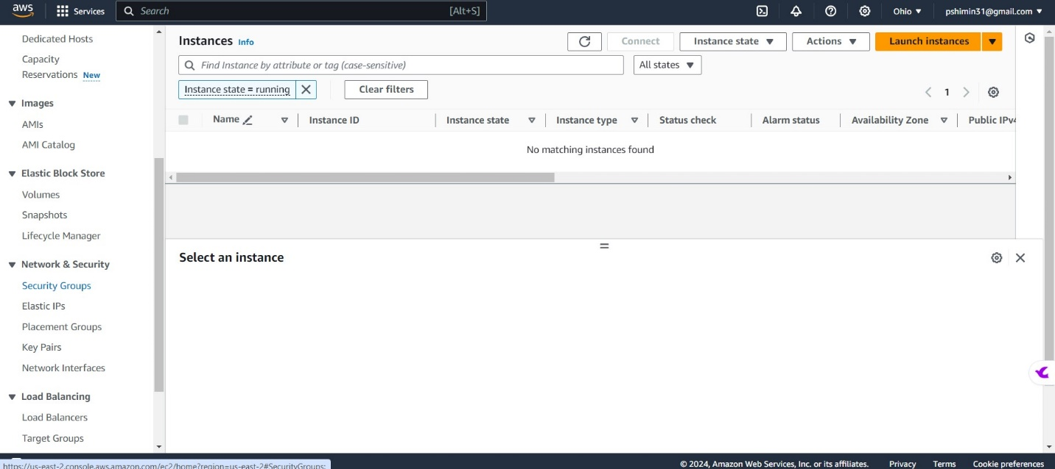

* you can see every time while creating an instance we make security will appear here , now we click on create security groups

* After that we will give the basic details such as name and description here i have given webser and under description i have write allow all http traffic so that anyone can access the webpage.

* After that in the inbound rule we will add rule and chose http and source is anywhere ,and will add another rule for ssh .

* Will hit on create security group and it will create the manual security group and all the details you bcan see in below screen capture,

**launching ec2 instance with user data for hosting a webpage**

* We have created a security group now we will create an instance give a name , choose Ami as Linux

* Choose instance type and go to the network setting

* Here we will select choose existing group and select the group we have created earlier my security group name is webserver so i chose webserver .

t

* Then we will scroll down to the end and choose the user data here we will give some script to update the package and giving permission and will write a simple text in our webpage

* When the status chck is passed will select an instance

* Will copy the public ip address and paste it into the new tab

* Finally i have created a simple webpage using ec2 instance and creating a manual security group.

**Instance Types :**

General Purpose Instances (T-Series):

These are good for small to medium-sized websites, basic software development, and lightweight apps. They're called "T" because they can handle sudden increases in CPU usage. T2 instances store extra CPU power when not in use, while T3 instances are faster overall and handle sudden CPU spikes better.

Compute Optimized Instances (C-Series):

These are for tasks that need a lot of computing power. They work well for things like processing lots of data at once, running powerful web servers, and doing complex scientific calculations.

Memory Optimized Instances (R-Series):

These are made for applications that need a ton of memory. They're great for handling large databases that need to keep lots of information in memory, and for running analytics programs that work with big data.

Storage Optimized Instances (I-Series):

These are perfect for apps that need super-fast storage. They're great for things like databases that need to quickly access lots of data, and for systems that handle large files. I-Series instances use special SSD storage that's really fast and helps apps run smoothly.

**Purchasing Options For Ec2 Instances**

On-Demand Instance:

You pay for the compute power you use by the hour or second, without any long-term commitments. This is good for apps that need flexibility to scale up or down quickly without paying upfront.

Reserved Instance:

You commit to using EC2 instances for one or three years and get a discount of up to 75% off the regular price. There are two types: Standard RIs, which lock in specific instance types, and Convertible RIs, which let you change instance features during the term.

Spot Instance:

You bid for unused EC2 capacity, which can lead to big savings compared to regular prices. However, your instance might be terminated if someone else bids higher or if capacity gets tight.

Dedicated Hosts:

You get your own physical server dedicated to your AWS account. This lets you use your own software licenses and gives you control over where your EC2 instances are placed on the server.

Dedicated Instance:

You get EC2 instances that use hardware specific to your AWS account, but they share the same physical hardware with other instances from your account.

schedule instance : you can schedule instances to start and stop automatically at specific times, such as during business hours or for periodic tasks. This is useful for saving costs by only running instances when they're needed, and for automating tasks like data processing or backups on a regular schedule.

**Storage Types:**

Block Storage:

Block storage is like a set of building blocks that you can connect to a computer. You can use it to store data in chunks, and it's really good for things like databases and big programs that need to access data quickly. Examples of block storage services are Amazon EBS, Azure Disk Storage, and Google Cloud Persistent Disks.

Object Storage:

Think of object storage as a huge warehouse where each item has its own unique label. It's great for storing large amounts of all kinds of files, like pictures, videos, and documents. Examples of object storage services are Azure Blob Storage, Google Cloud Storage, and Amazon S3.

File Storage:

File storage is like a giant filing cabinet where you can organize your files into folders. It's handy for sharing files between people or storing documents that need to be accessed by multiple users. Examples of file storage services are Amazon EFS, Azure Files, and Google Cloud Filestore.